

Houghton Regis Town Council

Cemetery Information & Regulations

Date of Approval: | 17th March 2004
Date of Review: | 30th August 2011; 9th November 2012; 7th September 2015; 15th July 2019; 7th February 2020, 7th June 2021

CONTENTS

Section Title Page

1 General Information 2

2 Cemetery Location and Layout 3

3 Hours of Opening 4

4 Burial Arrangements 4

5 Notice of Burial 5

5 Hours of Burial 5

6 Cemetery Fees 6

7 Exclusive Rights of Burial 6

8 Certificate of Burial or Cremation 7

9 Private Graves 7

10 Common Graves 7

11 Memorials 7
12 Maintenance of Graves, including Ashes Plots 9

13 Cemetery Rules 10

HOUGHTON REGIS TOWN COUNCIL CEMETERY INFORMATION

1. General Information

Houghton Regis Town Council manages the Houghton Regis Cemetery and takes pride in maintaining it to a high standard and creating an atmosphere of peace and tranquillity. Visitors to the Cemetery are asked to observe the regulations governing the Cemetery.

Enquiries concerning the Cemetery can be made to:

Houghton Regis Town Council
Peel Street
Houghton Regis
LU5 5EY

Tel: 01582 708540
E-mail: cemetery@houghtonregis-tc.gov.uk

The Council reserves the right to make additions and alterations to the regulations from time to time.

2. Cemetery Location and Layout

Cemetery Address:

Houghton Regis Cemetery
Cemetery Road
Houghton Regis
LU5 5BJ

Figure 1: Map Showing Cemetery Location
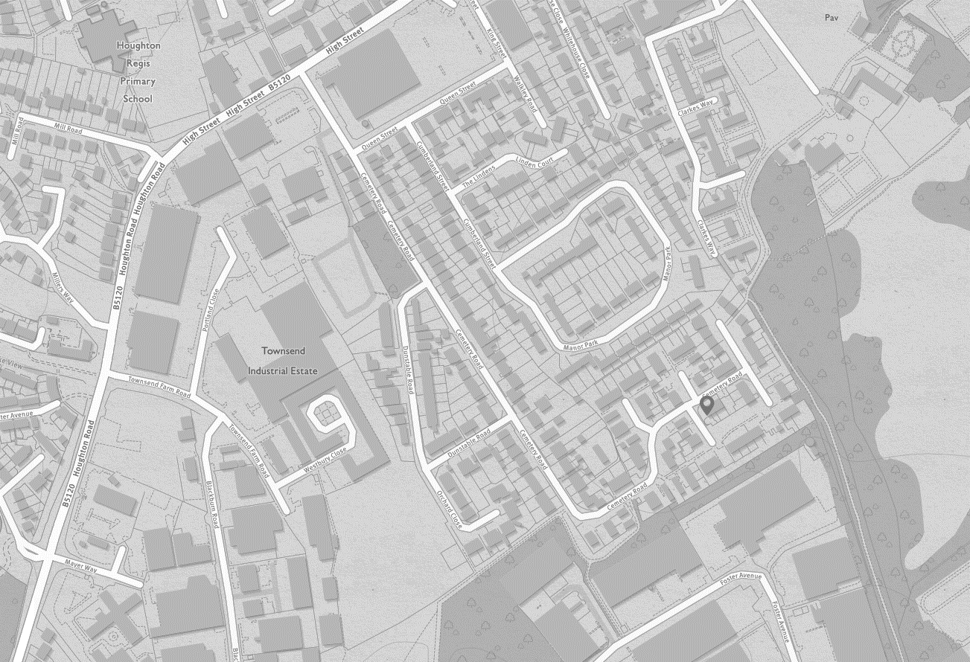
Houghton Regis Town Council Cemetery

Figure 2: Cemetery Layout

ENTRANCE
E N T R A N C E
STORAGE & REFUSE AREA

CREMATED REMAINS SECTION

CREMATED REMAINS SECTION

BABIES & CHILDRENS SECTION
GARDEN OF REMEMBRANCE
BURIAL SECTION

BURIAL SECTION

Information for Families and Friends

The Cemetery is open to the public throughout the year.

The Cemetery offers the following interment options:

Burials
There are 2 sections within the cemetery in which body burials can take place. Only second interments in existing burial spaces are now possible.

Ashes
The cemetery offers 2 types of ashes plots. The first is the interment of ashes in an earthen plot. The second is the placing of ashes in a vault in the Garden of Remembrance. Ashes may also be interred in burial plots, subject to space availability.

Memorials
Headstones can be placed, subject to approval, on burial and earthen ashes plots.
Headstones are provided as part of the Vault in the Garden of Remembrance.

Other
Please help us to maintain a high quality environment by:

Being respectful of others in the cemetery
- Place flowers in suitable receptacles and dispose of them in the bins provided

Placing litter and waste in the bins provided
- Keeping dogs on leads and under control

Cemetery Regulations

Burial Arrangements

Families can make arrangements for the burial of their loved one, either through a funeral director, or directly through the council.

Using a Funeral Director

When making arrangements through a funeral director, families will be guided through the process. The funeral director will take on the practical aspects of arranging the funeral, including:
- Organising the collection of your loved one from a hospital, nursing home or home address, and transport to the chosen funeral home
- Caring for the deceased and making a private chapel of rest available where family and friends can pay their last respects
- Guiding you through legal processes such as registering the death and completing documentation
- Liaising with the churchyard or cemetery to set the date and time of the funeral
- Paying disbursements such as crematorium fees on your behalf
- Arranging floral tributes and newspaper announcements if required
- Arranging your loved one’s journey to the place of the funeral service, and providing vehicles as required for family and mourners
Funeral directors seeking to work in Houghton Regis Cemetery must supply suitable insurance certification.
Booking direct with the council
Families are able to book interments directly with the council. The council will provide support and guidance to book the interment at the Houghton Regis Cemetery. Families will need to make their own arrangements for any additional services. Consideration should be given to the following, as these services are not provided by the council:
- Transportation (between place of death / crematorium / cemetery)
- Caring for the deceased and paying last respects
- Completing the legal processes
- Liaising with officiating minister / celebrant and the council
- Payment processes
- Floral tributes / donations / newspaper announcements

Notice of Burial

Written notice of burial on the Burial Arrangements form as supplied by the council must be given to the Town Council.

At least five clear working days (excluding Saturdays, Sundays and public holidays) must elapse between the day on which notice of burial is given and the day of the funeral. Alterations to arrangements within 5 working days of the interment may incur an extra administrative / grave preparation charge.

Hours of Burial

Burials may take place Monday to Friday inclusive, within the following burial times:

 | Monday – Thursday | Friday
Summer Period  1st April – 30th September | 9am to 3.30pm | 9am to 12.30pm
Winter Period  1st October to 31st March | 9am to 1.30pm | 9am to 12.30pm

Burials at weekends and public holidays may be permitted in cases of emergency. Out of hours fees will apply. The certificate of a coroner or registered medical practitioner confirming that immediate burial is necessary will be required.

Cemetery Fees

The current fee schedule for burials and memorials is available from the Council. Please note that there are parishioner fees and non-parishioner fees.

The Council’s fees for interments and memorial permits are paid at the time of booking through the Funeral Director / Memorial Mason or directly by the family.

Fees should be settled in advance of the interment.

Grant of Exclusive Right of Burial

In order to inter within the Cemetery, it is necessary for the Grant of Exclusive Right of Burial to be purchased for a particular grave space. This permits the purchaser, or their next of kin, (known as the Grantee) to decide who shall be interred in that grave and gives them control over any memorialisation on the plot.

The Grant of Exclusive Right of Burial does not give ownership rights to the purchaser.

Grave plots or earthen ashes plots cannot be pre-purchased, or a particular plot chosen, by the purchaser. The Council will allocate the next available plot.

Vaults within the Garden of Remembrance can be selected by the family and are available for pre-purchase.

Second or further interments will only be permitted in a grave when the Grant of Exclusive Right of Burial has been provided by the applicant or if the Grantee is the person to be interred.

The Grant of Exclusive Right of Burial provides rights over the plot for a specific time period, as follows:

Burial plots: 75 years
Earthen ashes plots: 75 years
Vaults: 20 years

The council will contact, by letter, the Grantee at approximately 12 months (and 6 months if necessary) prior to the end of the Grant period to see if the Grantee wishes to extend the period of the Grant of Exclusive Right of Burial or to seek further instruction. A request for the Grantee to contact the council will also be placed on the plot. In relation to ashes placed in Vaults in the Garden of Remembrance, should the Grantee not contact the council the ashes will be removed from the Vault along with the memorial and placed into storage for a 6 month period. At the end of the 6 month period the ashes will be scattered within the grounds of Houghton Regis Cemetery and the memorial will be destroyed.

Certificate of Burial or Cremation

A copy of the Certificate for Burial (or in the case of a still-born child, a certificate in accordance with the Births and Deaths Act, 1926) or Certificate of Cremation must be provided when the burial arrangements form is submitted.

The original must be produced at the time of the interment.

In the event that the original Certificate for Burial or Cremation is not supplied to the council at the time of the interment a Form 18 will have to be completed in order for the interment to take place.

In the event that certification is not supplied or the Form 18 not completed, the council will refuse to allow the interment to take place.

Private Graves (Those For Which An Exclusive Right of Burial is purchased)

The Council undertakes the preparation of plots within the cemetery.

Where more than one interment takes place in a burial plot there shall be a layer of earth not less than 15cm (6 inches) in thickness, plus the thickness of the coffin board, between each coffin. No part of any coffin shall be less than 1m (3 feet) below the level of the ground.

No burial plot shall be deepened after the first burial.

No burial plot shall be prepared and left open over a weekend or public holiday without suitable protection being put in place.

A casket containing cremated remains may, subject to space availability, be buried in any plot in the Cemetery for which the Exclusive Right of Burial has been purchased.

Common Graves (where no Exclusive Right of Burial has been purchased)

Common Graves shall be available for two burials.

No memorialisation may be erected on a common grave.

Memorials

Permission must be obtained, in advance, for the right to erect a memorial and the appropriate fee paid. Applications should be made by the Grantee or their lawful successor. In any other cases the consent of the Grantee will be sought. Memorial permits will not be issued without the consent of the Grantee

The application for a memorial must include an image of the memorial, dimensions, inscription wording and the design, and must be submitted to the Town Council for approval. It is strongly recommended that approval for the memorial be obtained prior to any costs being incurred.

The number of the grave, as shown in the interment book, must be placed on each memorial.

From 1st April 2021 the council will only permit BRAMM registered memorial masons to erect memorials within Houghton Regis Cemetery.

Memorial masons seeking to work in Houghton Regis Cemetery must supply suitable insurance certification, certificates of competence and details of their BRAMM registration.

Only Memorials within the following dimensions are permitted:

 | Height (max) | Width (max)
Burial Plots
- Headstone | 4’ 6” (135cm) | 2’6” (75cm)
- Wooden Cross | 4’ 6” (135cm) | 2’6” (75cm)
- Flat Stone | 12” (30cm) | 18” (45cm)
Children’s Burial Plots
- Headstone | 2’ 6” (75cm) | 1’ 6” (45cm)
- Wooden Cross | 2’ 6” (75cm) | 1’ 6” (45cm)
Ashes Plots
- Headstone | 12” (30cm) | 18” (45cm)
- Wooden Cross | 12” (30cm) | 18” (45cm)
- Vases | 10” (25cm)
- Tablet | 18” (45cm) | 18” (45cm)
Garden of Remembrance | The memorial is provided as part of the Vault. Families may select from a plaque, a book or a heart. The council can arrange for the inscription or families may choose to go to a memorial mason. No other memorials are permitted within the Garden of Remembrance.

The responsibility for the maintenance and repair of a memorial lies with the Grantee. The Town Council is not liable for any damage or wear and tear to a memorial through any cause other than its own negligence.

Temporary memorials are not permitted other than wooden crosses.

The council recommends that memorials are not installed until sufficient time has elapsed to enable the ground to settle (normally 6 months or so). Headstones being erected on a memorial pathway may be installed at any time after the interment.

For a subsequent interment to take place, it is the responsibility of the grantee, successor or person giving notice to arrange for the headstone and kerbing to be removed for the preparation of the grave.

Edging of any kind that stands above the level of the ground (soil), including kerbing and fencing of any material, is not allowed. Gravel, shingle, pebbles, slate or any other hard surfaced materials are not permitted on or around the graves and will be removed.

The Council reserves the right, after consultation with the grantee, to remove unauthorised memorials or any ornaments which in the Council’s opinion are offensive or inappropriate.

The Town Council undertakes a regular inspection of all memorials to ensure that they are in a good state of repair. Should the memorial be found to be in disrepair, the Council will undertake to contact the owner of the memorial by sending a letter to his/her last known address and displaying notice of its intention at the Cemetery, so that remedial action can be taken. Whilst attempts are made to trace the owner the Council reserves the right to lay a memorial down flat in order to ensure safety within the Cemetery. Should the owner not be traceable the Council reserves the right to remove the memorial.

Maintenance of Graves

Flowers and wreaths may be placed on and around the grave on the day of the funeral. Withered flowers and wreaths will be removed after 2 weeks by Council staff. Families are requested to remove any items they wish to keep before this time.

Cut flowers may be placed in suitable receptacles set into the memorial and its base.

Grave Plots

Planting is allowed in front of headstones of burial and earthen ashes plots, but must;
- Not exceed the width of the headstone;
- Only include bedding plants or low-level shrubs, which do not exceed 0.3m
(1ft) in height.

Planting is not permitted within the Garden of Remembrance. Flowers may be placed in the receptacles provided.

For all Plots

The Council reserves the right to bring any planting in line with these Regulations.

Where, in the opinion of the Council, the planting is not maintained and kept tidy, the Council may give instructions for the plants to be removed and the grave levelled and grassed over.

The Grantee may request (by letter or email) that the council level and grass over plots. This will be completed as soon as practicable after the request is made.

It is advised that ornaments are not left on plots to avoid the risk of damage or theft. The Council accepts no responsibility for any planting of graves or for any ornamentation left on plots.

Other

All visitors to the Cemetery are to park in the car park. No wheeled vehicles, other than invalid carriages, wheelchairs or perambulators may be taken onto the roadway around the Cemetery, except for vehicles attending funerals or bringing in materials or equipment for the placement of memorials, digging of graves etc. Such permitted vehicles shall keep to the roadway within the Cemetery.

Any person found in the Cemetery: -
wilfully creating any disturbance;
committing any nuisance;
wilfully interfering with any burial;
wilfully interfering with any grave, memorial, flowers or plants or any such matter: or
playing at any game of sport

is guilty of an offence and liable on summary conviction to a fine not exceeding £100 and in the case of a continuing offence to a fine not exceeding £10 for each day during which the offence continues after conviction.

The registers and records relating to the Cemetery are available, by appointment, for inspection at the Council Offices. Please contact the council to make an appointment.

IN ACCORDANCE WITH THE LOCAL AUTHORITIES’ CEMETERY ORDER 1977 THE COUNCIL RESERVES THE RIGHT TO MAKE AMENDMENTS TO THE REGULATIONS COVERING HOUGHTON REGIS CEMETERY.

The Council reserves the right to exclude the public should it be necessary at any time.
Local Authorities’ Cemeteries Order 1977 s18 and s19

